CSCI 2467
Lab 1

- Write a Java program that will produce the following output: Use the scanner method for input.

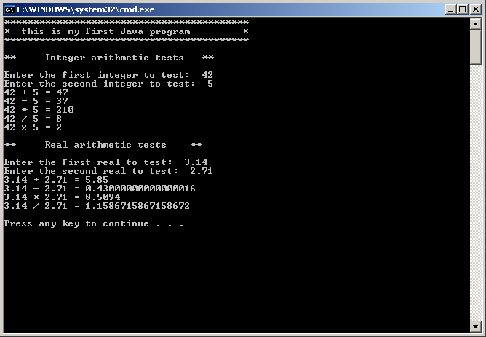

- Create a console splash screen that includes your name, address (make one up if you like), student email address, and the current date. Below is an example:

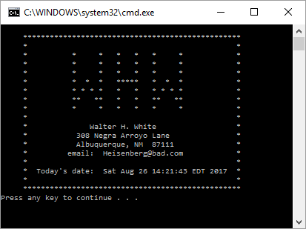

Submit both files via blackboard.

